# Download and Open the App

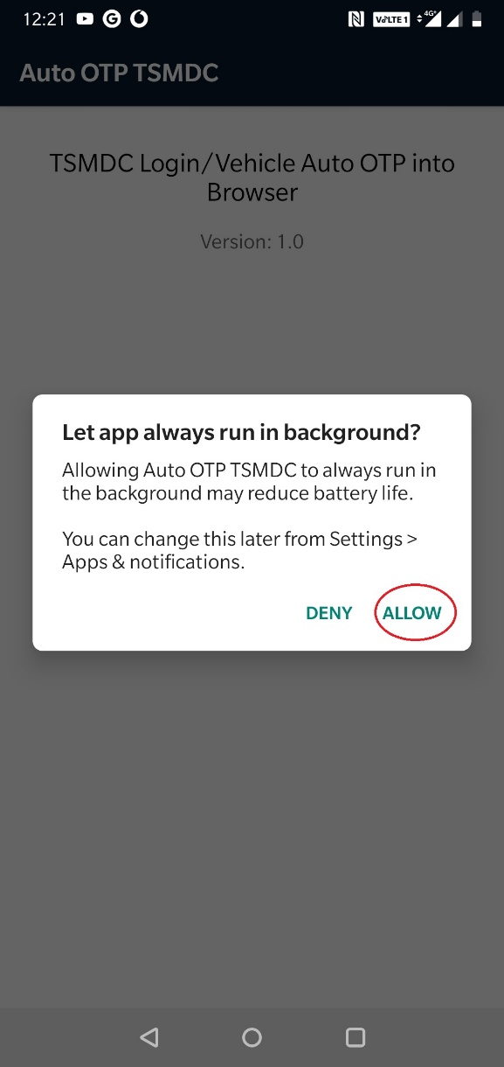

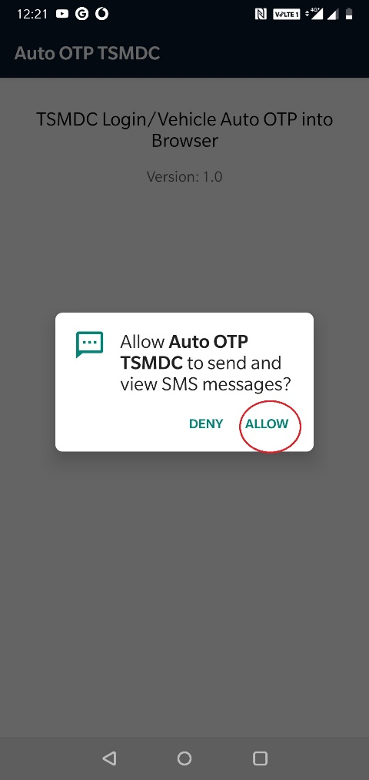

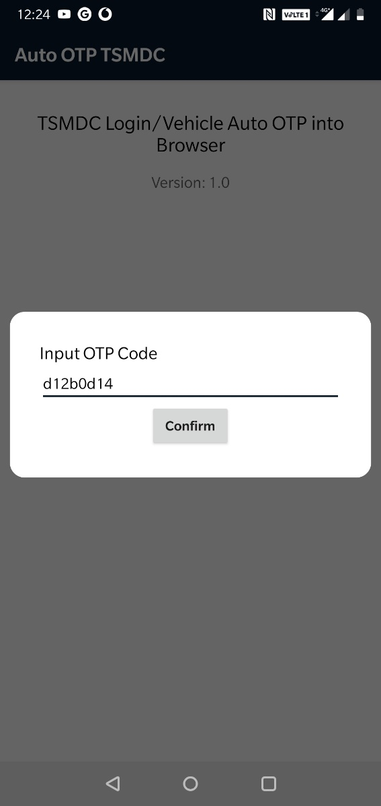

Enter Single time password. Delete the password once used. Press confirm 2 times

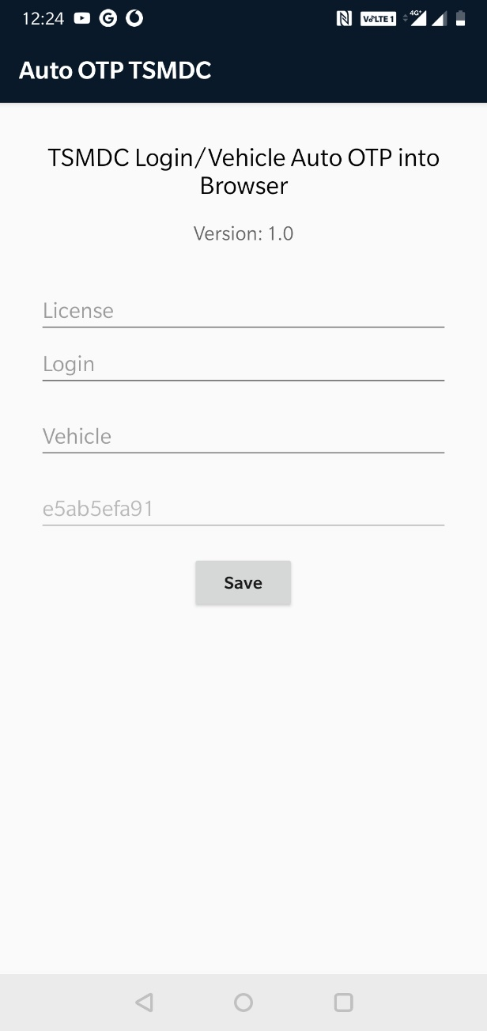

Enter same license here and in Greasymonkey script

Note this code and mobile name. Keep it in book. To block SMS from this mobile give this number

Enter only Idea/Voda/Jio/BSNL/Airtel. Bcause vehicle is in SMS so not used.

If this is vehicle SIM then don’t fill else enter mobile number. This phone should not have 2 login SIMs.

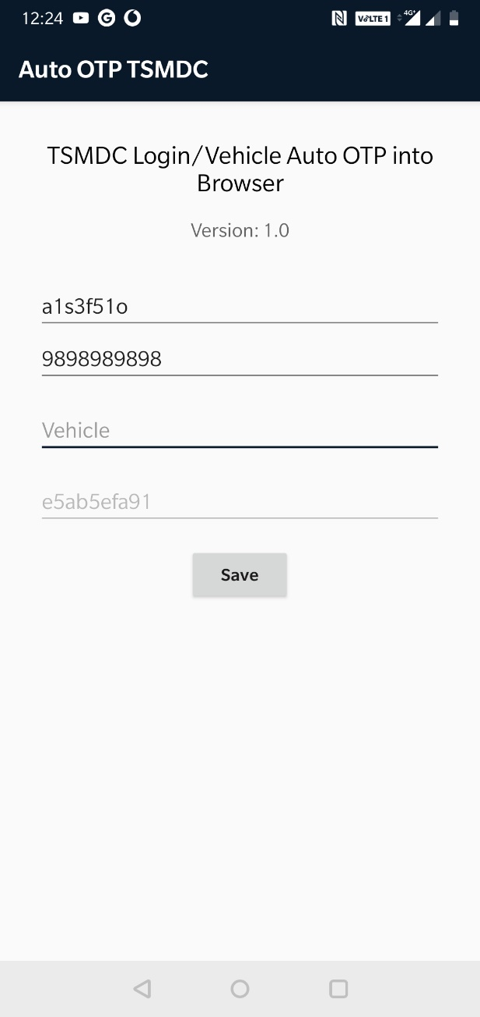

If Vehicle SIM then don’t fill this. Leave Empty

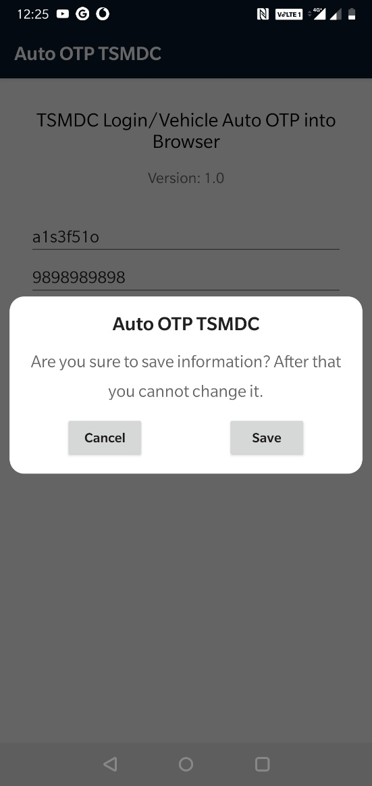

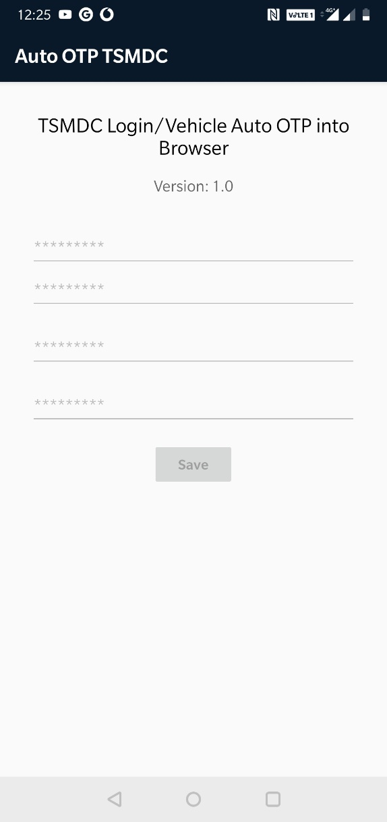

* Don’t use this app if mobile has 2 login SIMs
* If you want to change this data then uninstall and reinstall it
* For vehicle mobile leave Login empty
* Enable autostart and disable battery optimize etc else it don’t run in background
* After OTP codes over, you will get another 100 single time use codes for Rs. 100
* Enter same license correctly in greasymonkey script and in the app to get the OTP